PRACTICAL FILE
SESSION: 2023-24

Compiler Design Lab
(CIC 351)

III Year, V Sem

Submitted to: Submitted by:
Name: Dr Seema Verma Name: Adityan Verma
Designation: Professor Enrollment No. 07818002721

INDEX

S.NO. | PROGRAM NAME | DATE OF EXPERIMENT | DATE OF SUBMISSION | SIGN.
1 | About LEX/YACC of compiler writing
2 | Write a program to check whether a string belong to the grammar or not.
3 | Write a program to check whether a string include keyword or not.
4 | Write a program to remove Left Recursion from a grammar
5 | Write a program to perform Left Factoring on a grammar.
6 | Write a program to show all the operations of a stack.
7 | Write a program to find out the leading or FOLLOW of the non-terminal in a grammar.
8 | Write a program to Implement Shift Reduce parsing for a String.
9 | Write a program to find out the FIRST of the Non-terminals in a grammar.
10 | Write a program to check whether a grammar is operator precedence.

Experiment-1

AIM: About LEX/YACC of compiler writing.
Lexical Analysis
It is the first step of compiler design; it takes the input as a stream of characters and gives the output as tokens also known as tokenization. The tokens can be classified into identifiers, Separators, Keywords, Operators, Constant and Special Characters.
It has three phases:
- Tokenization: It takes the stream of characters and converts it into tokens.
- Error Messages: It gives errors related to lexical analysis such as exceeding length, unmatched string, etc.
- Eliminate Comments: Eliminates all the spaces, blank spaces, new lines, and indentations.

Lex
Lex is a tool or a computer program that generates Lexical Analyzers (converts the stream of characters into tokens). The Lex tool itself is a compiler. The Lex compiler takes the input and transforms that input into input patterns. It is commonly used with YACC(Yet Another Compiler Compiler). It was written by Mike Lesk and Eric Schmidt.

Function of Lex
- In the first step the source code which is in the Lex language having the file name ‘File.l’ gives as input to the Lex Compiler commonly known as Lex to get the output as lex.yy.c.
- After that, the output lex.yy.c will be used as input to the C compiler which gives the output in the form of an ‘a.out’ file, and finally, the output file a.out will take the stream of character and generates tokens as output.

Lex File Format
A Lex program consists of three parts and is separated by %% delimiters: -
Declarations:
%%
Translation rules
%%
Auxiliary procedures

Declarations: The declarations include declarations of variables.
Transition rules: These rules consist of Pattern and Action.
Auxiliary procedures: The Auxiliary section holds auxiliary functions used in the actions.
For example:
declaration
number[0-9]
%%
translation
if {return (IF);}
%%
auxiliary function
int numberSum()

YACC

- YACC stands for Yet Another Compiler Compiler.
- YACC provides a tool to produce a parser for a given grammar.
- YACC is a program designed to compile a LALR (1) grammar.
- It is used to produce the source code of the syntactic analyzer of the language produced by LALR (1) grammar.
- The input of YACC is the rule or grammar and the output is a C program.

These are some points about YACC:

Input: A CFG- file.y

Output: A parser y.tab.c (yacc)
- The output file "file.output" contains the parsing tables.
- The file "file.tab.h" contains declarations.
- The parser called the yyparse ().
- Parser expects to use a function called yylex () to get tokens.

Experiment-2

AIM: Write a program to check whether a string belong to the grammar or not.
Program:
#include <stdio.h>
#include <string.h>

int isBelongToGrammar(char *str) {
int len = strlen(str);
int i = 0;

while (i < len) {
if (str[i] == 'a') {
i++;
} else if (str[i] == 'b') {
i++;
while (i < len && str[i] == 'b') {
i++;
}
} else {
return 0;
}
}

// Check if the string ends in 'ab'
if (i == len || (i == len - 1 && str[i] == 'a')) {
return 1;
}
return 0;
}

int main() {
char input[100];

printf("\nThe grammar is :- \n S -> aS \n S -> Sb \n S -> ab\n\n");

printf("Enter a string: ");
scanf("%s", input);

if (isBelongToGrammar(input)) {
printf("String belongs to the grammar.\n\n");
} else {
printf("String does not belong to the grammar.\n\n");
}
return 0;
}

Output:

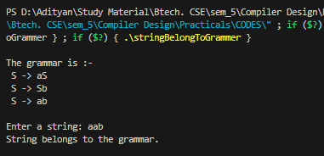
Experiment-3

AIM: Write a program to check whether a string include keyword or not.
Program:
#include <stdio.h>
#include <string.h>

int containsKeyword(const char *str, const char *keyword) {
if (strstr(str, keyword) != NULL) {
return 1; // Keyword found in the string
}
return 0; // Keyword not found in the string
}

int main() {
char input[500];
char keyword[20];

printf("\nEnter a string: ");
fgets(input, sizeof(input), stdin);
input[strcspn(input, "\n")] = '\0'; // Remove newline from fgets input

printf("Enter the keyword to check: ");
fgets(keyword, sizeof(keyword), stdin);
keyword[strcspn(keyword, "\n")] = '\0'; // Remove newline from fgets input

if (containsKeyword(input, keyword)) {
printf("\nThe string contains the keyword '%s'.\n", keyword);
} else {
printf("\nThe string does not contain the keyword '%s'.\n", keyword);
}

printf("\n");

return 0;
}

Output:

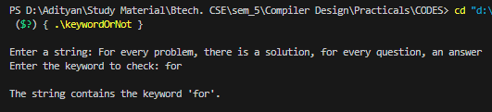

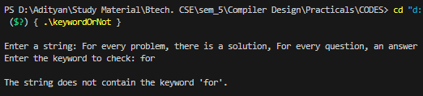
Experiment-4

AIM: Write a program to remove Left Recursion from a grammar.
Program:
#include <stdio.h>
#include <string.h>

#define SIZE 10

int main()
{
char non_terminal;
char beta, alpha;
int num;
char production[10][SIZE];
int index = 3;
printf("\nEnter Number of Production : ");
scanf("%d", &num);
printf("Enter the grammar :-\n");
for (int i = 0; i < num; i++)
{
scanf("%s", production[i]);
}
for (int i = 0; i < num; i++)
{
printf("\nGRAMMAR --> %s", production[i]);
non_terminal = production[i][0];
if (non_terminal == production[i][index])
{
alpha = production[i][index + 1];
printf(" is left recursive.\n\n");
while (production[i][index] != 0 && production[i][index] != '|')
index++;
if (production[i][index] != 0)
{
beta = production[i][index + 1];
printf("Grammar without left recursion:\n");
printf("%c->%c%c\'", non_terminal, beta, non_terminal);
printf("\n%c\'->%c%c\'|E\n", non_terminal, alpha, non_terminal);
}
else
printf(" can't be reduced\n");
}

else
printf(" is not left recursive.\n");
index = 3;
}

printf("\n");
return 0;
}

Output:

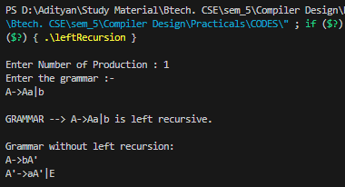

Experiment-5

AIM: Write a program to perform Left Factoring on a grammar
Program:
#include <stdio.h>
#include <string.h>
int main()
{
char gram[20], part1[20], part2[20], modifiedGram[20], newGram[20], tempGram[20];
int i, j = 0, k = 0, l = 0, pos;
printf("\nEnter Production : A->");
gets(gram);
for (i = 0; gram[i] != '|'; i++, j++)
part1[j] = gram[i];
part1[j] = '\0';
for (j = ++i, i = 0; gram[j] != '\0'; j++, i++)
part2[i] = gram[j];
part2[i] = '\0';
for (i = 0; i < strlen(part1) || i < strlen(part2); i++) {
if (part1[i] == part2[i]) {
modifiedGram[k] = part1[i];
k++;
pos = i + 1;
}
}
for (i = pos, j = 0; part1[i] != '\0'; i++, j++) {
newGram[j] = part1[i];
}
newGram[j++] = '|';
for (i = pos; part2[i] != '\0'; i++, j++) {
newGram[j] = part2[i];
}
modifiedGram[k] = 'X';
modifiedGram[++k] = '\0';
newGram[j] = '\0';
printf("\nGrammar Without Left Factoring :-\n");
printf(" A->%s", modifiedGram);
printf("\n X->%s\n", newGram);
printf("\n");
return 0;
}

Output:

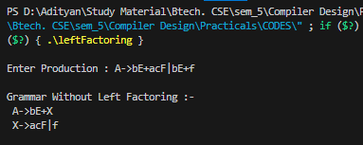

Experiment-6

AIM: Write a program to show all the operations of a stack. Program:
#include <stdio.h>
#include <stdlib.h>
#include <stdbool.h>

#define STACK_CAPACITY 100

struct Stack {
int top;
unsigned capacity;
int *array;
};

struct Stack *createStack(unsigned capacity) {
struct Stack *stack = (struct Stack *)malloc(sizeof(struct Stack));
if (stack == NULL) {
printf("Memory allocation failed.\n");
return NULL;
}
stack->capacity = capacity;
stack->top = -1;
stack->array = (int *)malloc(stack->capacity * sizeof(int));
if (stack->array == NULL) {
printf("Memory allocation failed.\n");
free(stack);
return NULL;
}
return stack;
}

bool isFull(struct Stack *stack) {
return stack->top == stack->capacity - 1;
}

bool isEmpty(struct Stack *stack) {
return stack->top == -1;
}

void push(struct Stack *stack, int item) {
if (isFull(stack)) {
printf("Stack overflow, can't push %d\n", item);
return;
}
stack->array[++stack->top] = item;
printf("%d pushed to stack\n", item);
}

int pop(struct Stack *stack) {
if (isEmpty(stack)) {
printf("Stack underflow, can't pop\n");
return -1; // Returning an arbitrary value to indicate underflow
}
int item = stack->array[stack->top--];
printf("%d popped from stack\n", item);
return item;
}

int peek(struct Stack *stack) {
if (isEmpty(stack)) {
printf("Stack is empty, no top element\n");
return -1; // Returning an arbitrary value to indicate empty stack
}
return stack->array[stack->top];
}

void freeStack(struct Stack *stack) {
free(stack->array);
free(stack);
printf("Stack memory freed\n");
}

int main() {
struct Stack *stack = createStack(STACK_CAPACITY);
if (stack == NULL) {
return -1; // Exiting due to memory allocation failure
}
printf("\n");

push(stack, 10);
push(stack, 20);
push(stack, 30);

pop(stack);
pop(stack);

pop(stack);
pop(stack); // Trying to pop from an empty stack

freeStack(stack);
printf("\n");
return 0;
}

Output:

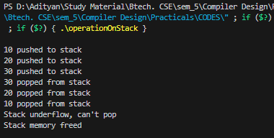

Experiment-7

AIM: Write a program to find out the leading or FOLLOW of the non-terminals in a grammar.
Program:
#include <ctype.h>
#include <stdio.h>
#include <string.h>

// Functions to calculate Follow
void followfirst(char, int, int);
void follow(char c);

// Function to calculate First
void findfirst(char, int, int);

int count, n = 0;

// Stores the final result
// of the First Sets
char calc_first[10][100];

// Stores the final result
// of the Follow Sets
char calc_follow[10][100];
int m = 0;

// Stores the production rules
char production[10][10];
char f[10], first[10];
int k;
char ck;
int e;

int main(int argc, char** argv)
{
int jm = 0;
int km = 0;
int i, choice;
char c, ch;
count = 8;

// The Input grammar
strcpy(production[0], "X=TnS");
strcpy(production[1], "X=Rm");
strcpy(production[2], "T=q");
strcpy(production[3], "T=#");
strcpy(production[4], "S=p");
strcpy(production[5], "S=#");
strcpy(production[6], "R=om");
strcpy(production[7], "R=ST");

int kay;
char done[count];
int ptr = -1;

// Initializing the calc_first array
for (k = 0; k < count; k++) {
for (kay = 0; kay < 100; kay++) {
calc_first[k][kay] = '!';
}
}
int point1 = 0, point2, xxx;

for (k = 0; k < count; k++) {
c = production[k][0];
point2 = 0;
xxx = 0;

// Checking if First of c has
// already been calculated
for (kay = 0; kay <= ptr; kay++)
if (c == done[kay])
xxx = 1;

if (xxx == 1)
continue;

// Function call
findfirst(c, 0, 0);
ptr += 1;

// Adding c to the calculated list
done[ptr] = c;
printf("\n First(%c) = { ", c);
calc_first[point1][point2++] = c;

// Printing the First Sets of the grammar
for (i = 0 + jm; i < n; i++) {
int lark = 0, chk = 0;

for (lark = 0; lark < point2; lark++) {

if (first[i] == calc_first[point1][lark]) {
chk = 1;
break;
}
}
if (chk == 0) {
printf("%c, ", first[i]);
calc_first[point1][point2++] = first[i];
}
}
printf("}\n");
jm = n;
point1++;
}
printf("\n");
printf("-----------------------------------------------"
"\n\n");
char donee[count];
ptr = -1;

// Initializing the calc_follow array
for (k = 0; k < count; k++) {
for (kay = 0; kay < 100; kay++) {
calc_follow[k][kay] = '!';
}
}
point1 = 0;
int land = 0;
for (e = 0; e < count; e++) {
ck = production[e][0];
point2 = 0;
xxx = 0;

// Checking if Follow of ck
// has already been calculated
for (kay = 0; kay <= ptr; kay++)
if (ck == donee[kay])
xxx = 1;

if (xxx == 1)
continue;
land += 1;

// Function call
follow(ck);
ptr += 1;

// Adding ck to the calculated list
donee[ptr] = ck;
printf(" Follow(%c) = { ", ck);
calc_follow[point1][point2++] = ck;

// Printing the Follow Sets of the grammar
for (i = 0 + km; i < m; i++) {
int lark = 0, chk = 0;
for (lark = 0; lark < point2; lark++) {
if (f[i] == calc_follow[point1][lark]) {
chk = 1;
break;
}
}
if (chk == 0) {
printf("%c, ", f[i]);
calc_follow[point1][point2++] = f[i];
}
}
printf(" }\n\n");
km = m;
point1++;
}
}

void follow(char c)
{
int i, j;

// Adding "$" to the follow
// set of the start symbol
if (production[0][0] == c) {
f[m++] = '$';
}
for (i = 0; i < 10; i++) {
for (j = 2; j < 10; j++) {
if (production[i][j] == c) {
if (production[i][j + 1] != '\0') {
// Calculate the first of the next
// Non-Terminal in the production
followfirst(production[i][j + 1], i,
(j + 2));
}

if (production[i][j + 1] == '\0'
&& c != production[i][0]) {
// Calculate the follow of the
// Non-Terminal in the L.H.S. of the
// production
follow(production[i][0]);
}
}
}
}
}

void findfirst(char c, int q1, int q2)
{
int j;

// The case where we
// encounter a Terminal
if (!(isupper(c))) {
first[n++] = c;
}
for (j = 0; j < count; j++) {
if (production[j][0] == c) {
if (production[j][2] == '#') {
if (production[q1][q2] == '\0')
first[n++] = '#';
else if (production[q1][q2] != '\0'
&& (q1 != 0 || q2 != 0)) {
// Recursion to calculate First of New
// Non-Terminal we encounter after
// epsilon
findfirst(production[q1][q2], q1,
(q2 + 1));
}
else
first[n++] = '#';
}
else if (!isupper(production[j][2])) {
first[n++] = production[j][2];
}
else {
// Recursion to calculate First of
// New Non-Terminal we encounter
// at the beginning
findfirst(production[j][2], j, 3);
}
}
}
}

void followfirst(char c, int c1, int c2)
{
int k;

// The case where we encounter
// a Terminal
if (!(isupper(c)))
f[m++] = c;
else {
int i = 0, j = 1;
for (i = 0; i < count; i++) {
if (calc_first[i][0] == c)
break;
}

// Including the First set of the
// Non-Terminal in the Follow of
// the original query
while (calc_first[i][j] != '!') {
if (calc_first[i][j] != '#') {
f[m++] = calc_first[i][j];
}
else {
if (production[c1][c2] == '\0') {
// Case where we reach the
// end of a production
follow(production[c1][0]);
}
else {
// Recursion to the next symbol
// in case we encounter a "#"
followfirst(production[c1][c2], c1,
c2 + 1);
}
}
j++;
}
}
}

Output:
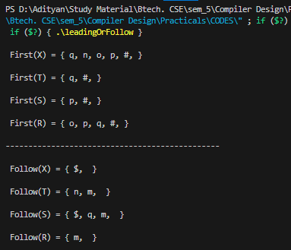
Experiment-8

AIM: Write a program to Implement Shift Reduce parsing for a String.
Program:
#include <stdio.h>
#include <stdlib.h>
#include <string.h>

int z = 0, i = 0, j = 0, c = 0;
char a[16], ac[20], stk[15], act[10];

void check() {
strcpy(ac, "REDUCE TO E -> ");
for (z = 0; z < c; z++) {
if (stk[z] == '4') {
printf("%s4", ac);
stk[z] = 'E';
stk[z + 1] = '\0';
printf("\n$%s\t%s$\t", stk, a);
}
}

for (z = 0; z < c - 2; z++) {
if (stk[z] == '2' && stk[z + 1] == 'E' && stk[z + 2] == '2') {
printf("%s2E2", ac);
stk[z] = 'E';
stk[z + 1] = '\0';
stk[z + 2] = '\0';
printf("\n$%s\t%s$\t", stk, a);
i = i - 2;
}
}

for (z = 0; z < c - 2; z++) {
if (stk[z] == '3' && stk[z + 1] == 'E' && stk[z + 2] == '3') {
printf("%s3E3", ac);
stk[z] = 'E';
stk[z + 1] = '\0';
printf("\n$%s\t%s$\t", stk, a);
i = i - 2;
}
}
}

int main() {
printf("\nGRAMMAR is :-\nE->2E2 \nE->3E3 \nE->4\n");
strcpy(a, "32423");
c = strlen(a);
strcpy(act, "SHIFT");
printf("\nstack \t input \t action");
printf("\n$\t%s$\t", a);

for (i = 0; j < c; i++, j++) {
printf("%s", act);
stk[i] = a[j];
stk[i + 1] = '\0';
a[j] = ' ';
printf("\n$%s\t%s$\t", stk, a);
check();
}

check();

if (stk[0] == 'E' && stk[1] == '\0') {
printf("Accept\n");
} else {
printf("Reject\n");
}

printf("\n");
return 0;
}

Output:
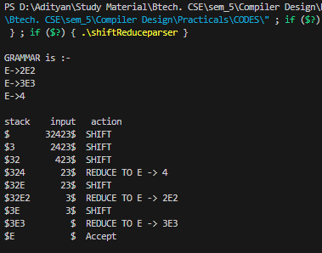

Experiment-9
AIM: Write a program to find out the FIRST of the Non-terminals in a grammar.
Program:
#include <stdio.h>

char array[10][20], temp[10];
int c, n;

int fun2(int i, int j, int p[], int key); // Function prototype

void fun(int i, int p[])
{
int j, k, key;
for (j = 2; array[i][j] != '\0'; j++)
{
if (array[i][j - 1] == '/')
{
if (array[i][j] >= 'A' && array[i][j] <= 'Z')
{
key = 0;
fun2(i, j, p, key);
}
else
{
key = 1;
if (fun2(i, j, p, key))
temp[++c] = array[i][j];
if (array[i][j] == '@' && p[0] != -1) // taking '@' as null symbol
{
if (array[p[0]][p[1]] >= 'A' && array[p[0]][p[1]] <= 'Z')
{
key = 0;
fun2(p[0], p[1], p, key);
}
else if (array[p[0]][p[1]] != '/' && array[p[0]][p[1]] != '\0')
{
if (fun2(p[0], p[1], p, key))
temp[++c] = array[p[0]][p[1]];
}
}
}
}
}
}

int fun2(int i, int j, int p[], int key)
{
int k;
if (!key)
{
for (k = 0; k < n; k++)
if (array[i][j] == array[k][0])
break;
p[0] = i;
p[1] = j + 1;
fun(k, p);
return 0;
}
else
{
for (k = 0; k <= c; k++)
{
if (array[i][j] == temp[k])
break;
}
if (k > c)
return 1;
else
return 0;
}
}

int main()
{
int p[2], i, j;
printf("Enter the no. of productions :");
scanf("%d", &n);
printf("Enter the productions :\n");
for (i = 0; i < n; i++)
scanf("%s", array[i]);
for (i = 0; i < n; i++)
{
c = -1, p[0] = -1, p[1] = -1;
fun(i, p);
printf("First(%c) : [ ", array[i][0]);
for (j = 0; j <= c; j++)
printf("%c,", temp[j]);
printf("\b ].\n");
}

return 0;
}

Output:

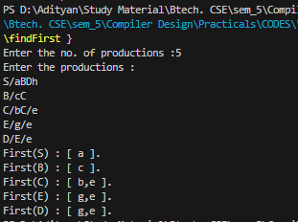
Experiment-10
AIM: Write a program to check whether a grammar is operator precedence.
Program:
#include<stdlib.h>
#include<stdio.h>
#include<string.h>

// function f to exit from the loop
// if given condition is not true
void f()
{
printf("Not operator grammar");
exit(0);
}

void main()
{
char grm[20][20], c;

// Here using flag variable,
// considering grammar is not operator grammar
int i, n, j = 2, flag = 0;

printf("\nInput: ");
scanf("%d", &n);
for (i = 0; i < n; i++)
scanf("%s", grm[i]);

for (i = 0; i < n; i++) {
c = grm[i][2];

while (c != '\0') {

if (grm[i][3] == '+' || grm[i][3] == '-'
|| grm[i][3] == '*' || grm[i][3] == '/')

flag = 1;

else {

flag = 0;
f();
}

if (c == '$') {
flag = 0;
f();
}

c = grm[i][++j];
}
}

if (flag == 1)
printf("Operator grammar");
}

Output:

